Co1 Assessment Tool 1: -Case Study Analysis

SMART VERTICAL FARMING AUTOMATION PLATFORM
Name: -G. Akshya Reg.No: -192425132
Slot-D Course Code: -CSA1007 1. Problem Understanding
Problem: Vertical farming requires continuous monitoring of environmental conditions. Manual monitoring leads to inefficient irrigation, inconsistent lighting, delayed crop disease detection and resource wastage.
Introduction:
- Agriculture is one of the most important sectors for ensuring food security and supporting the global economy.
- However, traditional farming methods face several challenges, including limited agricultural land, unpredictable climate conditions, water scarcity, increasing labor costs, and inefficient resource utilization.
- These challenges make it difficult to produce high-quality crops consistently while meeting the growing food demands of an increasing population.
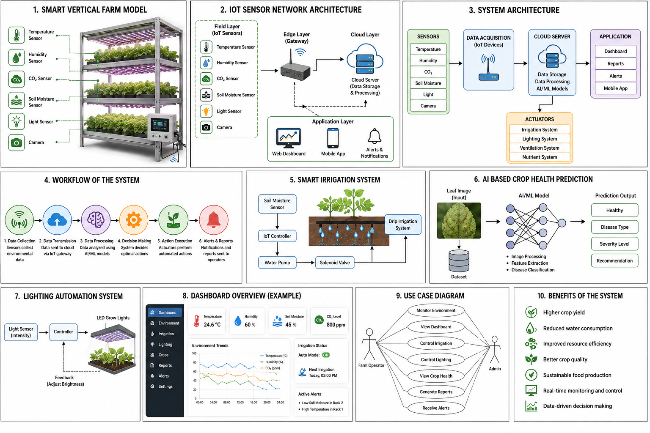
Objectives:
- Monitor environmental conditions
- Optimize irrigation
- Predict crop health
- Automate lighting
- Generate reports
- Notify operators
2. Stakeholder Analysis
Stakeholders: Farm Owner, Farm Operators, Agricultural Experts, IoT Engineers, System Administrator, Customers, Government.
Roles and challenges are explained through monitoring, maintenance, decision making, compliance and quality assurance.
3. Current System Analysis
Existing systems rely on manual monitoring and fixed schedules. Strengths: simple and low cost. Weaknesses: high labour, water wastage, delayed disease detection, no real-time analytics.
4. Proposed Software Solution
Modules:
• Environmental Monitoring
• Smart Irrigation
• Crop Health Prediction
• Lighting Automation
• Report Generation
5. Requirements
Functional: Login, monitor sensors, automate irrigation, control lighting, generate reports, notifications.
Non-functional: Security, Reliability, Scalability, Maintainability, Performance, Usability.
6. Software Engineering Principles
Modularity, Scalability, Maintainability, Reliability, Security and Usability are applied using independent modules, cloud architecture, authentication, backups and responsive dashboards.
7. SDLC Justification
Agile Scrum is selected because farming requirements evolve. Short sprints, continuous testing, customer feedback and incremental delivery reduce project risk.
8. Expected Outcomes
Higher crop yield, reduced water consumption, improved resource efficiency, better crop quality and sustainable food production.
9. Risks and Limitations
- Sensor failures
- Internet dependency
- Implementation cost
- Cybersecurity risks and hardware maintenance.
10. Future Enhancements
Drone monitoring, blockchain traceability, weather integration, voice assistant, renewable energy integration.
Conclusion
The Smart Vertical Farming Automation Platform combines IoT, AI and cloud computing to improve agricultural productivity and sustainability while following Software Engineering principles.
Code of Content: -
I G. Akshya (192425132) Name / Reg No) certify that this submission is my
original work and that I have adhered to the guidelines specified for this assessment.
I understand that any violation of academic integrity rules will result in disciplinary
action.
Signature of the student: G. Akshya

